**Cybersecurity Basic Task**

**Google Dork-Based Asset Discovery**

- M.Manurajan 107124065

1.Target domain: tesla.com

1. Public Documents (PDF, XLSX, DOCX, etc)

Dork used: site:tesla.com filetype:xls OR filetype:xlsx OR filetype:doc OR filetype:docx OR filetype:ppt OR filetype:pptx OR filetype:pdf

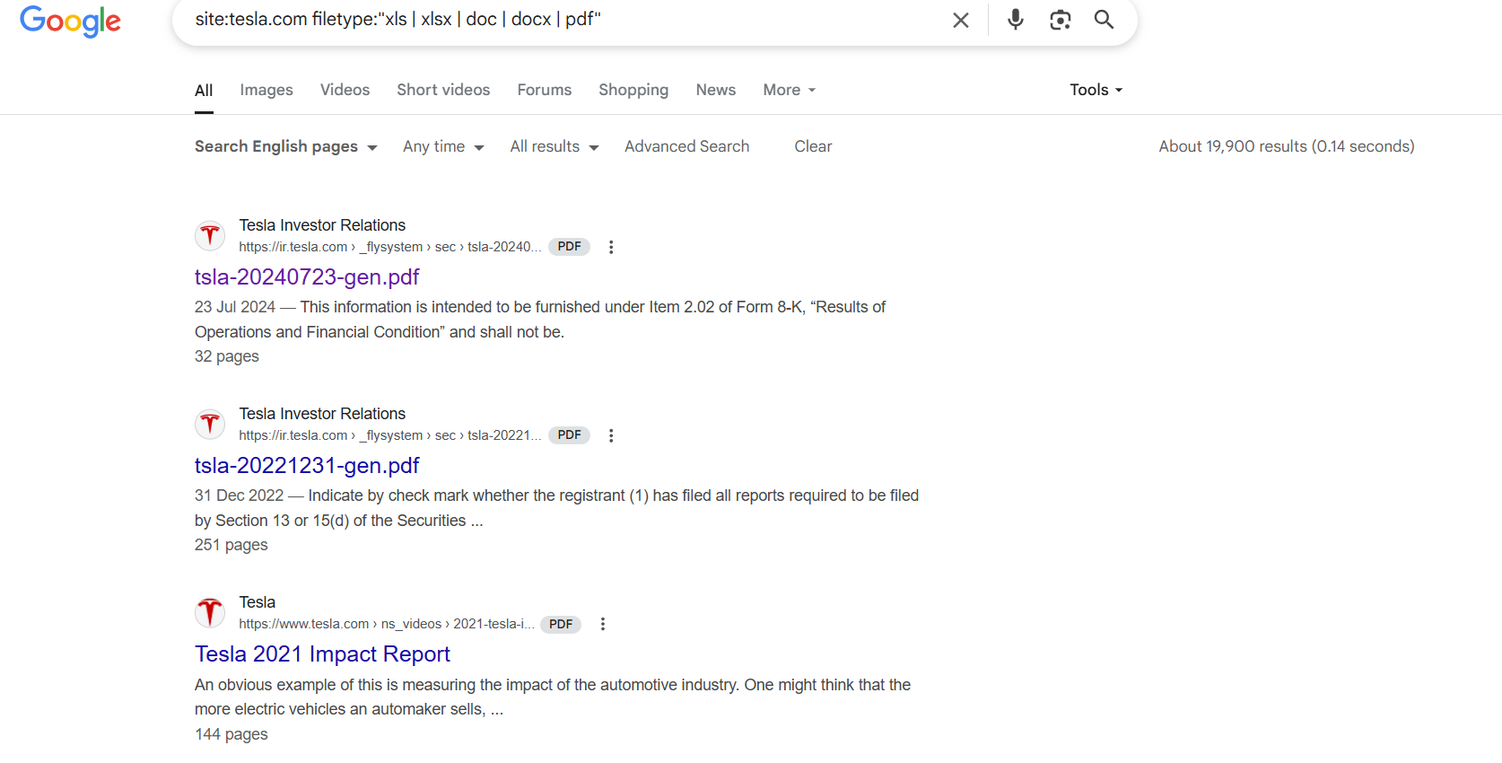

2. Login Pages / Admin Panels

Dork used: site:tesla.com inurl:login

<https://www.tesla.com/en_GB/user/login>

<https://www.tesla.com/teslaaccount>

<https://sso.tesla.com/adfs/ls/?SAMLRequest=fZDBbsIwEER%2FJfIdME4lpFUSyW1ySNVSihGH3oxriaiOnXjXgvL1TeFCL73Pm6eZAnXvBpCJjn5rx2SRsr2N2AVfMjHnLGvrkjXhwXw2u%2Bbx6BVdDpf0bN4bNabxLKcAYrKtR9KeJoYLPuP5TIgdX0HOYbmaL0X%2BwbJz7zzC1VeyFD0EjR2C171FIANKvr7ApIQhBgomOFYVv2m4CuId%2Fz%2BuEW2kaQCrNtsalHoDGdNBry2dQvzCYnHXelMMsJ5q2noTXGe%2BM%2BlcOD1Fq8mWjGKybFHdqL9PVT8%3D&RelayState=pg86YzW1exr6uu54rySWGOsspNhVVy>

3. Public Backup / Config Files

Dork used: site:tesla.com intitle:"index of" "config.php"

No results found :(

4. Exposed Logs / Errors

Dork used: site:tesla.com intitle:"index of" errors.log

No results found :(

5. Emails & Contact Info

Dork used: site:tesla.com filetype:txt intext:"@gmail.com" intext:"contact"

No results found :(

6. Git Folders and Env Files

Dork used: site:tesla.com intitle:"index of" (".env" OR ".git")

No results found :(

2.Target domain: starbucks.com

1. Public Documents (PDF, XLSX, DOCX, etc)

Dork used: site:starbucks.com filetype:xls OR filetype:xlsx OR filetype:doc OR filetype:docx OR filetype:ppt OR filetype:pptx OR filetype:pdf

<https://www.google.com/url?sa=i&url=https%3A%2F%2Finvestor.starbucks.com%2Ffiles%2Fdoc_financials%2F2020%2Fq2-20-10q.pdf&psig=AOvVaw23Gm8Y2smEI_hrRPtvscb3&ust=1748260142351000&source=images&cd=vfe&opi=89978449&ved=0CAQQn5wMahcKEwignfPWxr6NAxUAAAAAHQAAAAAQBA>

<https://www.google.com/url?sa=i&url=https%3A%2F%2Finvestor.starbucks.com%2Ffiles%2Fdoc_financials%2F2021%2Fq4-21-10k.pdf&psig=AOvVaw23Gm8Y2smEI_hrRPtvscb3&ust=1748260142351000&source=images&cd=vfe&opi=89978449&ved=0CAQQn5wMahcKEwignfPWxr6NAxUAAAAAHQAAAAAQBg>

<https://www.google.com/url?sa=i&url=https%3A%2F%2Finvestor.starbucks.com%2Ffiles%2Fdoc_financials%2FAnnual_Report_2003_part1.pdf&psig=AOvVaw3hK8D_KFC8eqJuiiqlCG6t&ust=1748261128839000&source=images&cd=vfe&opi=89978449&ved=0CAQQn5wMahcKEwjIjcCtyr6NAxUAAAAAHQAAAAAQBA>

1. Login Pages / Admin Panels

Dork used: site:starbucks.com inurl:login

<https://www.google.com/url?sa=i&url=https%3A%2F%2Fapply.starbucks.com%2Fcandidate%2Flogin&psig=AOvVaw1NIZ9HN6sX1yTlfnBWRQ-1&ust=1748261562069000&source=images&cd=vfe&opi=89978449&ved=0CAYQrpoMahcKEwj4muf7y76NAxUAAAAAHQAAAAAQBA>

<https://www.google.com/url?sa=i&url=https%3A%2F%2Falumni.starbucks.com%2Flogin%2Flogin-username%2F&psig=AOvVaw1NIZ9HN6sX1yTlfnBWRQ-1&ust=1748261562069000&source=images&cd=vfe&opi=89978449&ved=0CAYQrpoMahcKEwj4muf7y76NAxUAAAAAHQAAAAAQBg>

<https://www.google.com/url?sa=i&url=https%3A%2F%2Fsgsmsupplier.starbucks.com%2FSupplierPortal%2FLogin.aspx&psig=AOvVaw1NIZ9HN6sX1yTlfnBWRQ-1&ust=1748261562069000&source=images&cd=vfe&opi=89978449&ved=0CAYQrpoMahcKEwj4muf7y76NAxUAAAAAHQAAAAAQCA>

1. Public Backup / Config Files

Dork used: site:starbucks.com intitle:"index of" "config.php"

No results found :(

1. Exposed Logs / Errors

Dork used: site:starbucks.com intitle:"index of" error.log

No results found :(

1. Emails & Contact Info

Dork used: site:starbucks.com filetype:txt intext:"@gmail.com" intext:"contact"

No results found :(

1. Git Folders and Env Files

Dork used: site:starbucks.com intitle:"index of" (".env" OR ".git")

No results found :(

3. Target domain: cmu.edu

1. Public Documents (PDF, XLSX, DOCX,etc)

Dork used: site:cmu.edu filetype:xls OR filetype:xlsx OR filetype:doc OR filetype:docx OR filetype:ppt OR filetype:pptx OR filetype:pdf

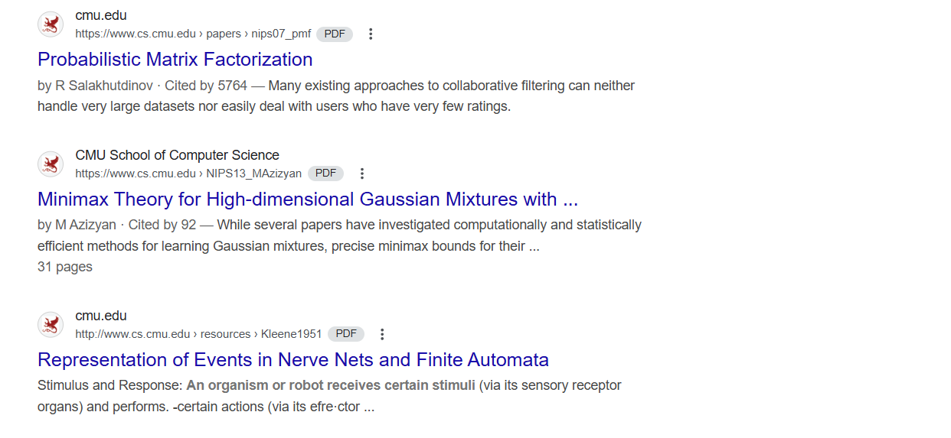

2. Login Pages / Admin Panels

Dork used: site:cmu.edu inurl:login

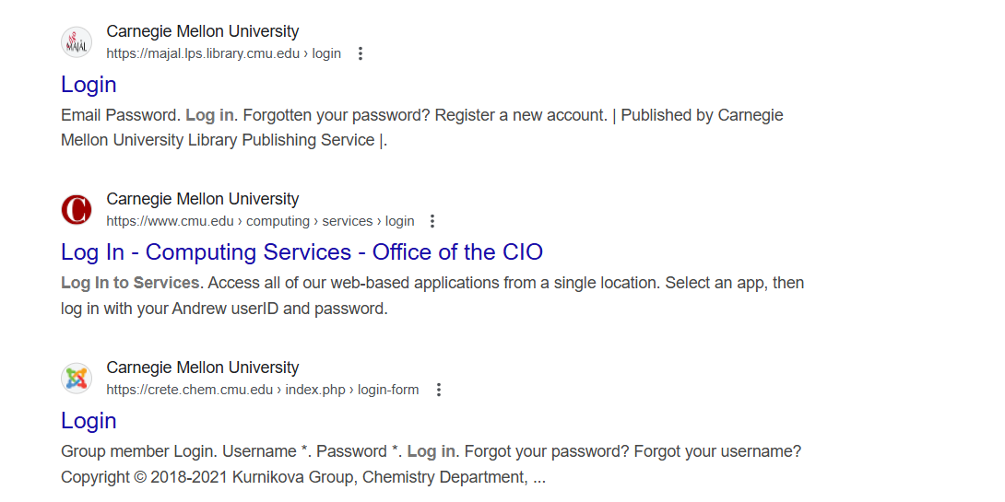

3. Public Backup / Config Files

Dork used: site:cmu.edu intitle:"index of" "config.php"

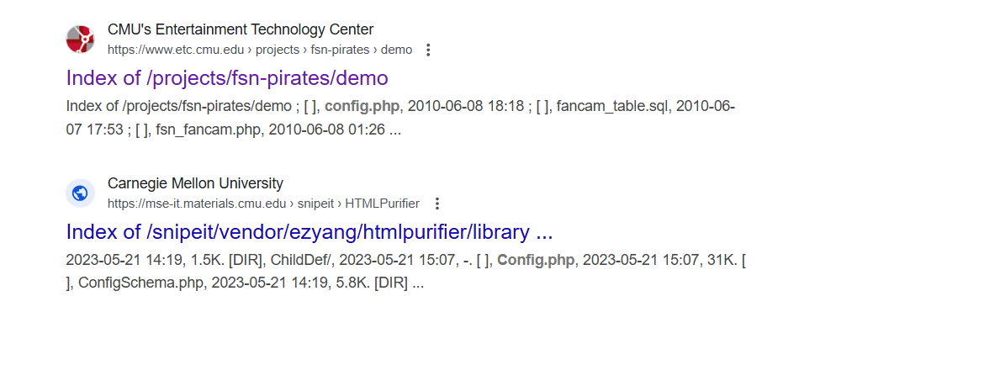

4. Exposed Logs / Errors

Dork used: site:cmu.edu intitle:"index of" error.log

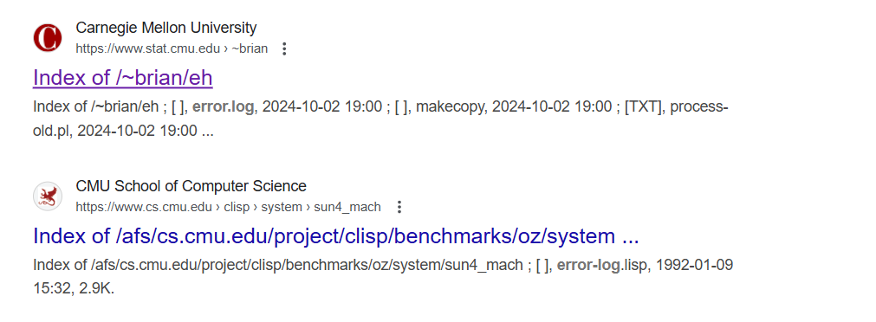

5. Emails & Contact Info

Dork used: site:cmu.edu filetype:txt intext:"@gmail.com" intext:"contact"

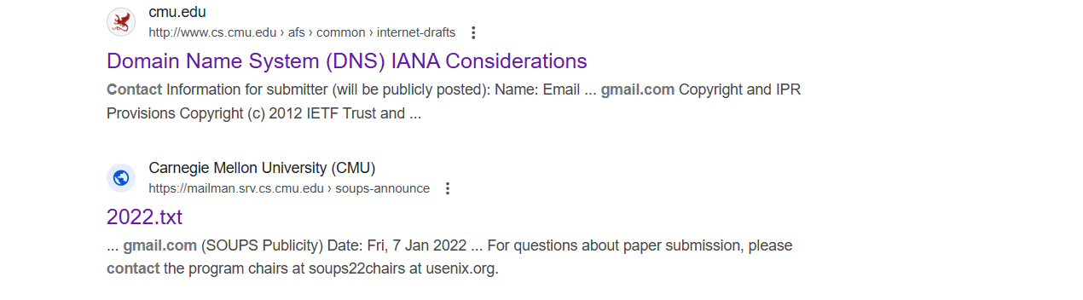

<http://www.cs.cmu.edu/afs/andrew/common/internet-drafts/draft-ietf-appsawg-json-merge-patch-07.txt>

6. Git Folders and Env Files

Dork used: site:cmu.edu intitle:"index of" ".env" OR ".git"

<https://www.cs.cmu.edu/~fp/courses/comp-ded/elf/env/>